**High power double-end pumped efficient MHz self-mode-locked Pr:YLF green and red lasers**

**Saiyu Luo, Bin Xu, Huiying Xu, Zhiping Cai1,\***

*Department of Electronic Engineering, Xiamen University, Xiamen 361005, China*

*\*E-mail:* [xubin@xmu.edu.cn](mailto:xubin@xmu.edu.cn), zpcai@xmu.edu.cn

**Abstract:** We demonstrate an efficient tens and hundreds of MHz self-mode-locked green and red lasers in a Pr3+:YLF4 crystal with V-type and Z-type cavity using a double-end-diode-pumped structure without the need of any additional components. Thanks to the double-end pumped scheme, with an absorbed pump power of ~2.8 W, more than 0.68 W average output power operating in the cw mode locked state with a slop efficiency of 29.9% with respect to the absorbed pump power for 522 nm green laser and more than 1.44 W with a slop efficiency of 57.3% for 639 nm red laser were obtained. The output pulse trains and power spectrums demonstrate steady mode-locked operations at the maximum output power for hours. The spectral width (FWHM) of the 639 nm self-mode-locked operation with an effective cavity length of 1.61 m was measured to be 0.39 nm. Mechanism for the self-mode-locking effect were also analyzed.

**Keywords:** Solid state laser, Blue diode-double-end pump, Pr:YLF crystal,visible laser source, (140.4050) Mode-locked lasers; (190.3270) Kerr effect.

**1. Introduction**

Mode locking operations in the visible spectral region were first realized in the middle of 1990s. The first mode-locked Pr3+:YLiF4 visible lasers at 607 and 639 nm utilizing the Kerr-lensing effect and initiated by liquid saturable absorbers were realized in 1995 by introducing argon-ion lasers as the pump source. [1995 Kerr-lens]. For the two wavelengths, 18 mW and 34 mW was achieved with repetition rate of 125 MHz and pulse width of 9.7 ps and 8.5 ps, respectively, which is the shortest optical pulse in the visible spectral region. One year later, the first self-staring Kerr-lens mode locked laser at 607 nm with output power of 15 mW and pulses width of 15 ps was reported by using Pr3+:YLiF4 as the gain media, which was also pumped by an argon-ion laser [1996 Self-starting]. Almost ten years leter, In 2014, with the help of highly efficient pump source, 2ω-OPSL, the first semiconductor saturable absorber mirror (SESAM) mode-locked praseodymium solid-state laser at 640 nm was obtained by Gaponenko et al, with pulses duration of ∼18 ps and repetition rate of 85.6 MHz. [2014 SESAM]. Due to the narrow gain bandwidth of the transition (3P0→3F2) in the Pr3+:YLF, generating mode-locked sub-picosecond pulses is challenging. The maximum averaged output power reached 16 mW at an incident pump power of 3.75 W.

In the past one year, the wavelength of self-mode-locked visible pulsed lasers extent to the spectral range of green and deep red for the first time [2016 Pr:GLF]. The system used Pr:GLF as the gain material and was pumped by laser-diode and the repetition rates were multi-gigahertz (GHz), which indicates a compact cavity configuration. The maximum output power reached 612 mW with the slope efficiency of 46.9% at 639 nm. The obtained pulse widths range from 53 ps to 74 ps, which were 5~7 times larger than previous work. Following closely, still by introducing a SESAM, but pumped by InGaN laser-diode, which is different from Gaponenko et al, mode-locking operation at the wavelength of 640 nm was attained. [2016 SESAM]. a maximum averaged output power of 65 mW was obtained at absorbed pump power of 3.8 W, with a pulse width of 45 ps (FWHM) at a pulse repetition rate of 108 MHz. Recently, passive mode-locking with the help of two-dimensional photoelectric material MoS2 was first realized at 522, 608 and 639 nm with output powers of 10, 18 and 46 mW, respectively [2017 MoS2]. The achieved pulse width were 25-55 ps with repetition rates of ~100 MHz.

**2. Experimental Set-Up**

Figure 1 depicts the experimental setup for the self-mode-locked Pr:YLF red laser with a ~1.8 m length Z-type cavity using a double-end pumping scheme. The active medium was an a-cut 0.2 at. % Pr3+:YLF4 crystal with a length of ~8 mm. Both end surfaces of the Pr3+:YLF4 crystal were plano and uncoated. The laser crystal was wrapped with indium foil to improve the thermal contact and mounted in a water-cooled copper holder. The water temperature was maintained around 18°C to eliminate thermal effect. The laser crystal was placed close to IM1, which is the input mirror for the pump on the left side. IM2 is the input mirror for the pump on the right side and was tilted with respect to the pump to make the cavity longer. Both IM1 and IM2 had high transmission (>95%) at ~444 nm and high reflection (>99.8%) at 639 nm.

Each of the two pump sources was a commercially available ~1.8 W, ~444 nm single-mode LD with achromatic and collimation systems. By using single-mode diode pumping, sufficient self-focusing, which may result in self-mode-locking, could be expected owing to the relatively smaller cavity mode size compared with multi-mode pumping, since single-mode diode pumping tends to induce single-mode laser oscillation.

Focusing lenses with 50 mm focal length was used to inject the pump beam into the laser crystal with an average pump size of approximately 65 μm, which is measured by using Spiricon M2-200.

HR1~HR3 were concave mirrors with radius of curvature of 300 mm and had high reflection (>99.7%) at 639 nm, which could provide positive feedback for 639 nm lasing. The output coupler (OC) was a coated plane mirror with a transmission of 3.5% at 639 nm. The distance between IM1 and IM2 plus the distance between IM2 and HR1 equals ~300 mm. The distance between HR1 and HR2 and the distance between HR2 and HR3 were both around 600 mm. The distance between HR3 and OC was ~300 mm.

Theoretically, taking all these distances into account, the total cavity length was ~1.8 m.

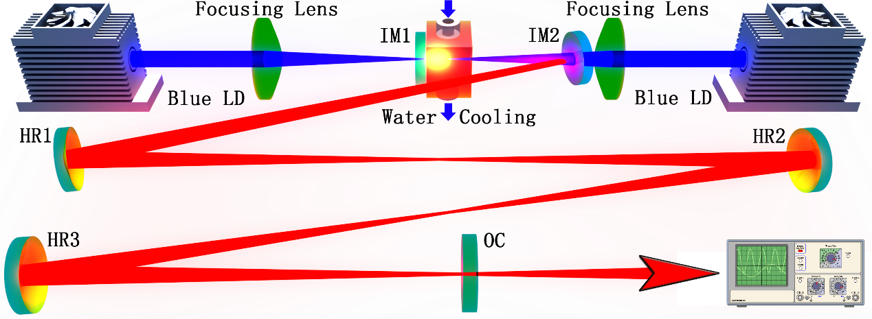

Fig. 1. Schematic of the Z-type self-mode-locked Pr3+:YLF4 red laser.

Moreover, to make sure the registered pulse train was mode-locked and its frequency could be changed by altering cavity length, for 639 nm self-mode-locked lasing operation, experiments with a V-type cavity and concave OC with a radius of curvature of 300 mm was conducted, making the cavity length ~0.3 m. Besides, self-mode-locked laser operation in the green spectral range was also conducted by using the same V-type schematic using different IMs and OC for 522 nm. For the 522 nm self-mode-locked laser, the two input mirrors IM1 and IM2 had a high transmission (> 95%) for the pump (~444 nm), high reflection (> 99.9%) at 522 nm to support lasing and high transmission (> 60%) around 607 and 639 nm to suppress the high gain emissions at those wavelengths. The concave output coupler had a radius of curvature of 300 mm and transmission of 1.9% at 522 nm.

**3. Experimental results and discussions**

For the Z-type cavity shown in Figure 1 operating at 639 nm, the optical cavity length was firstly set to be approximately 1.8 m, corresponding to a FSR of 83.3 MHz. Than the cavity length and alignment was optimized for generating the maximum average output power. Thanks to the double-end pumping scheme, more than 1.44 W output power was extracted with a total laser slop efficiency of 57.3% with respect to the absorbed pump power. In the experiment, the left and right pump LDs were turned on in turn. The lasing performance was shown by the red dots and line depicted in Figure 2.

For the green self-mode-locked Pr3+:YLF4 laser operating at the wavelength of 522 nm, which adopted a ~0.3 m V-type cavity using OC with a transmission of 1.9%, owing to the double-end pumping scheme, up to ~0.68 W average output power at mode-locked state was obtained, with a total laser slop efficiency of 29.9% with respect to the absorbed pump power as shown by the green dots and line sketched in Figure 2.

The reason why we did not manage to extend the cavity length of the green self-mode-locked laser might result from the fact that the green laser is more susceptible to the air conditions, which might limit the transmitting distance in the atmosphere, especially when considering intra-cavity transmitting.

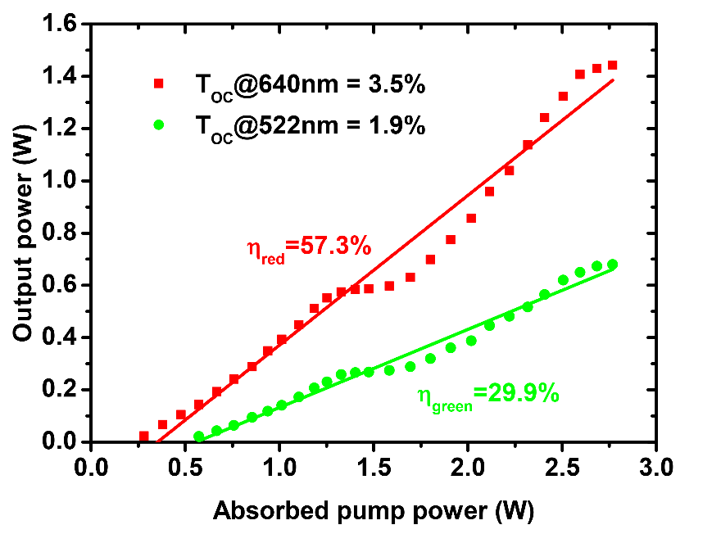

Fig. 2. Self-mode-locked laser performance of the ~1.8 m cavity 639 nm (red) and ~0.3 m 522 nm (green) laser operations.

It is worth noting that the flat points at the absorbed pump power of 1.4~1.6 W shown in Figure 2 were caused by the introduction of double-end pumping scheme and the way we record the input-output relation, which is by first turning one pump to maximum and then another. Another notable feature for the laser performance is that the double-end pumping scheme could lead to a better lasing performance compared with individual pumping, which might belong to the increased overlapping efficiency that the pump interacts with laser cavity modes when two pump beams were injected from both ends.

The optical spectrum for 639 nm laser operated in self-mode-locked state was shown in Figure 4. The spectrum was registered by Hewlett Packard 8560E Series Optical Spectrum Analyzer with a resolution of 0.08 nm under maximum pump power and meanwhile, a photo detector and digital oscilloscope was used to monitor the laser output to ensure that the laser was operated in mode-locked state. As shown in Figure 4, the center wavelength was 639.4 nm, and the spectral width (FWHM) was measured to be 0.39 nm. In fact, the measured spectrum shows some internal structures.

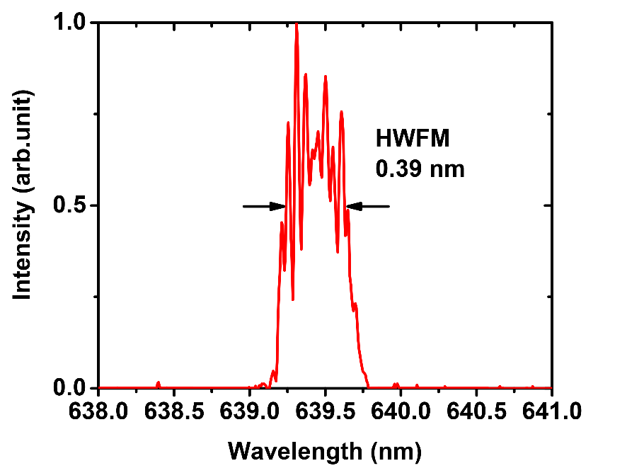

Fig. 3. Optical spectrum of the self-mode-locked Pr3+:YLF4 laser for 639 nm at cavity length of ~1.8 m measured at the maximum pump power.

The mode-locked pulses trains were detected by a free space high sensitivity PIN photo detector unit (Menlo Systems, Inc. FPD310-FV with rise time 0.7 ns), whose output signal was connected to a digital mixed signal oscilloscope (Tektronix MSO 3054) with 500 MHz electrical bandwidth and a sampling interval of 0.4 ns. The pulse trains were measured from the output of one of the high reflection mirrors (HR1~HR3) at the same time the maximum emitting laser powers from output coupler (OC) were measured. This has the advantage of both ensuring that the lasers were in mode-lock state while optimizing output power, and protecting the photo detector by letting few energies hit on it.

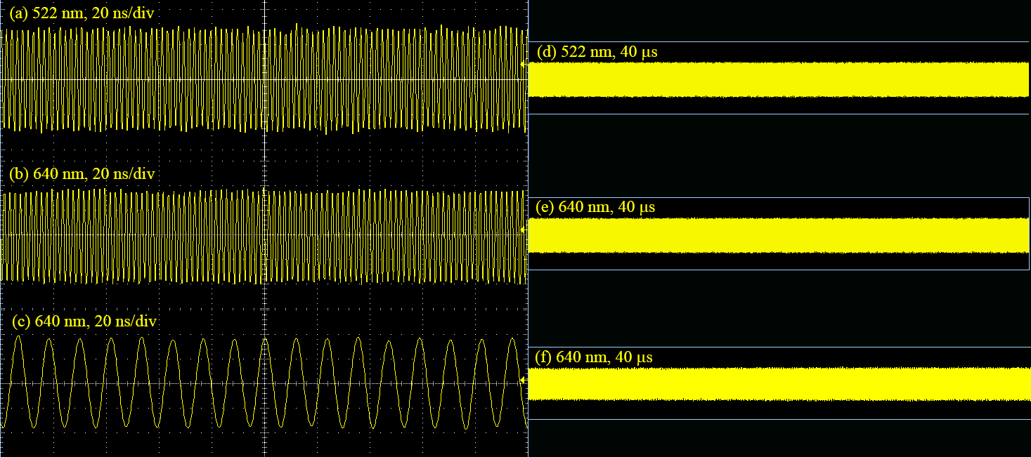

Fig. 4. Output pulse trains of the self-mode-locked lasers operating at the wavelength of 522 nm and 639 nm with a cavity length of ~0.3 m ((a), (b), (d), (e)) and ~1.8 m ((c), (f)) in time span of 200 ns ((a), (b), (c)) and 40 μs ((d), (e), (f)).

Figure 4 shows the measured pulse train results for the self-mode-locking operated at the wavelength of 522 nm (Figure 4(a), Figure 4(d)) and 639 nm (Figure 4(b), Figure 4(e)) with a cavity length of ~0.3 m, and 639 nm with a cavity length of ~1.8 m (Figure 4(c), Figure4(f)), respectively, on two different time scales. The figures on the left side of Figure 4 are the ones with time span of 200 ns, demonstrating mode-locked pulses, and the figures on the right side of Figure 4 are the ones with time span of 40 μs, demonstrating the amplitude stability. It can be seen that the pulse trains display full modulation, and the complete mode locking is achieved. In fact, the stable mode-lock oscillation could be maintained for a few hours at the maximum output power without changes of the output characteristics.

Unfortunately, the sampling rates of our photo detector and digital oscilloscope were not sufficient enough to detect the details of the pulse trains and the single pulse traces could neither be depicted, because the auto-correlation function analyzer in our lab was not available in the visible spectral range.

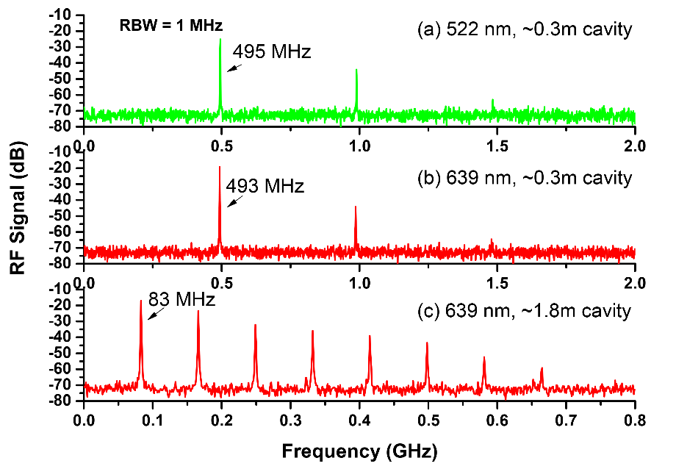

Fig. 5. Power spectrum of the self-mode-locked lasers operating at the wavelength of 522 nm and 639 nm with a cavity length of ~0.3 m ((a), (b)) and ~1.8 m ((c)) at a resolution of 1 MHz.

The power spectrums of the mode-locking outputs were detected by FPD310-FV, whose output signal was transferred to an rf spectrum analyzer (GωINSTEK, GSP-930) with a bandwidth of 3.0 GHz. The results were also recorded through one of the three high reflection mirrors (HR1~HR3) when maximum output powers were achieved.

As is depicted in Figure 5(a), repetition rate of 495 MHz was registered for the V-type cavity operating at 522 nm, indicating an effective cavity length of 303 mm when the cavity was optimized for the maximum output power. By introducing the same V-type cavity, but switching cavity mirrors for the 639 nm laser emitting, repetition rate of 493 MHz was recorded as shown in Figure 5(b), deducing an effective cavity length of 304 mm when the maximum output power was achieved. Regarding the Z-type cavity operating at the wavelength of 639 nm, the corresponding power spectrum is plotted in Fig. 3(c), which shows eight harmonic frequencies with the fundamental repetition rate of 83 MHz, leading to a cavity length of 1805 mm, demonstrating an excellent stability of the self-mode-locking operation to some extent. Note that the cavity lengths that were calculated according to the measured fundamental frequencies when maximum output power were achieved were 3~5 mm longer than the expected cavity length. It might be attributed to the fact that since the cavity was double-end pumped, the laser beam waist in the gain media was moved from the end close to IM1 to the center of the laser crystal, in order to obtain a larger overlapping efficiency.

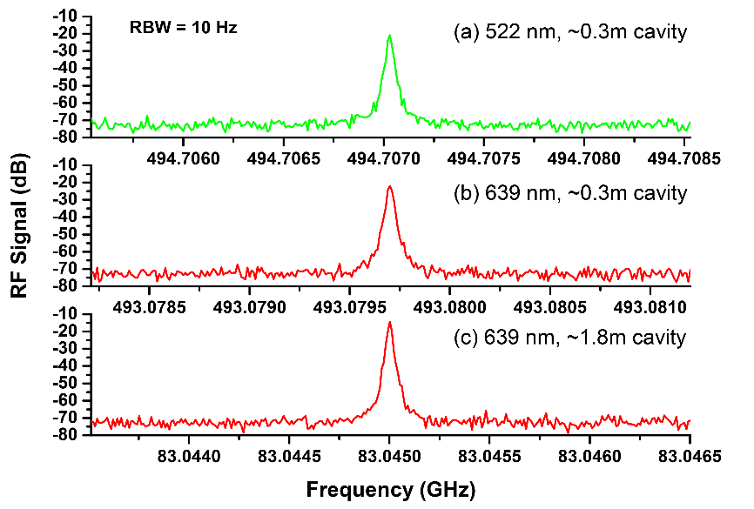

Fig. 6. Power spectrum of the self-mode-locked lasers operating at the wavelength of 522 nm and 639 nm with a cavity length of ~0.3 m ((a), (b)) and ~1.8 m ((c)) at a bandwidth of 3 kHz and resolution of 10 Hz.

The detail of the fundamental frequencies were measured as shown in Figure 6. As is demonstrated in Figure 5 and Figure 6, the lasers were cw mode locked with only weak noise, the signal to noise ratio of the fundamental resonance frequencies were experimentally found to be ~50 dB.

It deserves noting that once the lasing threshold is reached by appropriately adjusting the laser cavity, the laser system steps into a stable mode-locked operation instantaneously, with no need of any mechanical perturbation. The locking mechanism is presumed to be the Kerr effect. Bai et al. [Novel self-mode-locking mechanism in narrow-band lasers] proposed a novel self-mode-locking mechanism in narrowband lasers based on the analysis of the gain-line splitting induced by an intra-cavity laser field.

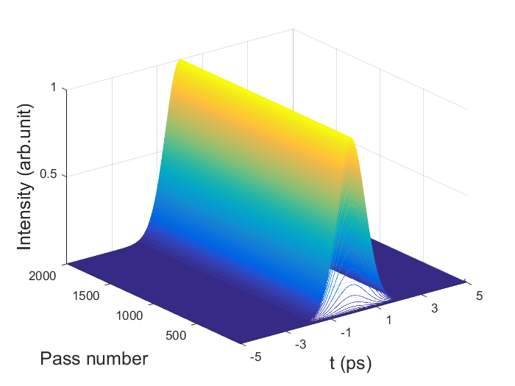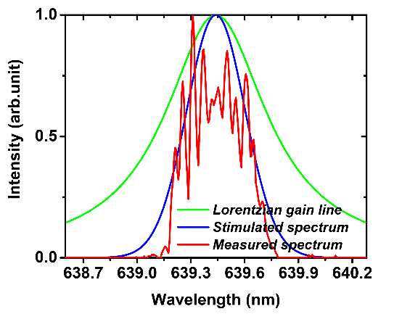

**(b)**

**(a)**

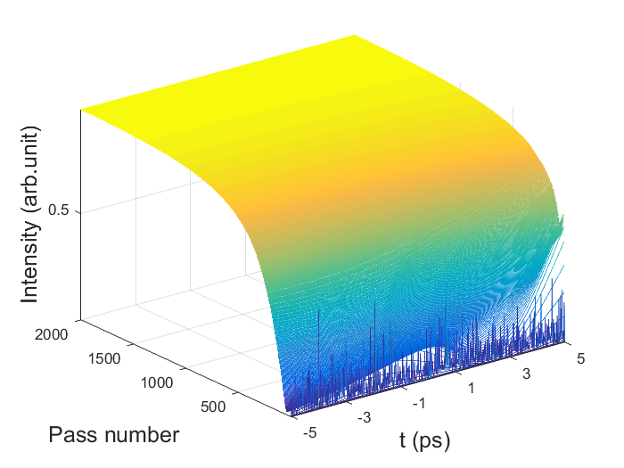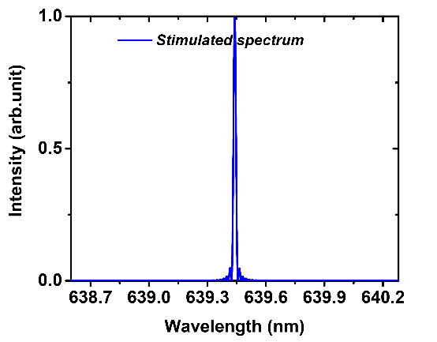

**(d)**

**(c)**

Fig 7. Simulated pulse evolution and final spectrum without frequency shift caused by gain line splitting. (a) and (b) are the situations with intensity modulation; (c) and (d) are situations without intensity modulation.

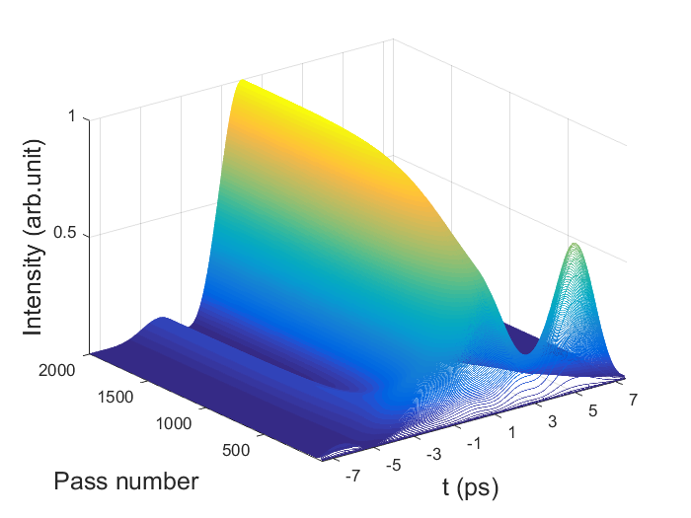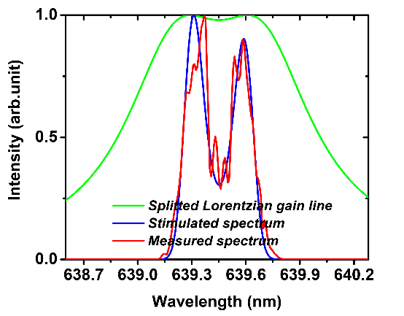

**(a)**

**(b)**

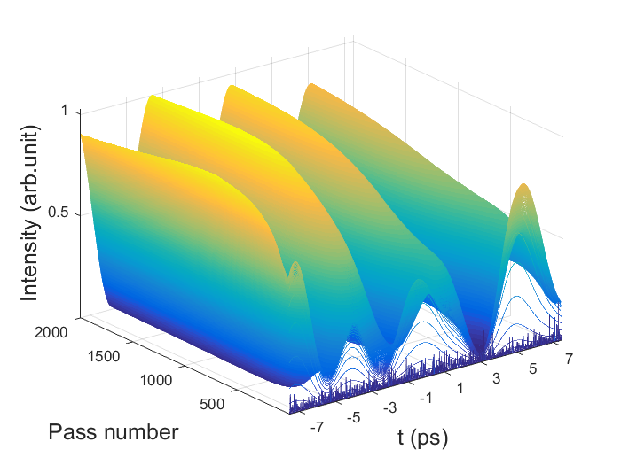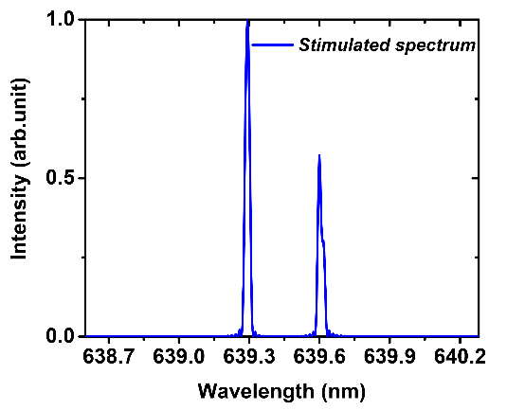

**(d)**

**(c)**

Fig 8. Simulated pulse evolution and final spectrum with frequency shift caused by gain line splitting. (a) and (b) are the situations with intensity modulation; (c) and (d) are situations without intensity modulation.

The model of the self-started Kerr-lens mode-locking procedure consists of a laser gain media and an intensity modulator. The laser gain media can be thought of as an amplifier that has a gain line shape, which can be modeled by a frequency filter. As for the amplifier, the saturation effect should also be taken into account and its effect on the gain factor *g* is given as

,(1)

Where *g*ss is the small-signal gain factor, *P* is the signal power, *P*sat is the saturation power. With regard to the gain line shape, Pr3+:YLF laser is solid-state laser with a gain-line shape corresponds to Lorentzian profile which belongs to homogeneous broadening [2016, Li Qing-Song]. The gain coefficient can be expressed as

,(2)

among which *ν*0 is the central frequency and *Δν* is Full Width at Half Maximum (FWHM) of the laser gain-line shape. For the 3P0→3F2 transition line at 640 nm, *Δλ* is 0.69 nm, leading to a *Δν* of 506.2 GHz. Owing to the spatial-temporal narrowing of the signal by Kerr-lensing effects of the gain media, the intensity of the intracavity laser is modulated passively. The model of the intensity modulation can be briefly thought of as a Gaussian profile in the time domain and be written as

,(3)

where *t*0 is the reference time, and *Δt* is the FWHM of the modulation signal.

After the laser crystal, the signal propagates in the atmosphere, where it experiences no chromatic dispersion or nonlinear effect, and is governed by the linear differential equation

,(4)

where *L* is the cavity round-trip loss, and can be solved by using the finite element method. After one round trip, the signal is fed in the gain media again and completes another round trip. The process is repeated until equilibrium is reached.

The simulation results that coincides with the FWHM of the measured spectrum depicted in Figure 7 (b), which was 0.39 nm, is depicted in Figure 7(a) and (b). In this simulation, the FWHM of the modulation signal *Δt* was tuned to 3.5 ps so that the FWHM of the calculated spectrum was also 0.39 nm. As is shown in Figure 7(a), a stable optical pulse was obtained with a pulse width of 1.5 ps, leading to a time-bandwidth product of 0.427, meaning a transform limited result. As a comparison, simulations with no intensity modulation was also carried out, the response in time domain and the simulated wavelength are illustrated in Figure 7(c) and (d), respectively. As can be seen, the result in the time domain becomes a direct current signal, and the FWHM of the simulated wavelength was shortened, corresponding to a continuous-wave operation state.

It is interesting to note that, in our experiments, meanwhile the laser was mode-locked, laser spectrums with a relatively big dip in the center shown as the red line in Figure 8(b) were sometimes captured. The possible reason for the dip in the laser spectrum is the frequency shift caused by gain-line splitting [93, Zhijiang Wang]. By introducing a frequency shift of the Stark splitting *Δνs* from the unperturbed frequency induced by the intra-cavity laser field, Eq. (2) can be written as

,(5)

By substituting Eq. (5) into the system instead of Eq. (2) and adjusting the frequency shift *Δνs* to 176 GHz (corresponding to a wavelength of 0.16 nm)and modulation duration in Eq. (3) to 45 ps, we can obtain a simulated spectrum almost identical to the registered one shown as the red line in Figure 8(b), with a FWHM of 0.39 nm. As shown in Figure 8(a), the FWHM of the corresponding optical pulse was 2.4 ps, resulting in a time-bandwidth product of 0.936. It should be noted that, to get the simulation results, the duration of intensity modulation model raised almost 13 times compared with the case without frequency shift resulted from gain line splitting, which reveals the fact that the stark shift has the effect of modulating intensity, or in another word, compressing optical pulses. This conclusion is consistent with the experimental results reported by J. J. Sanchez-Mondragon in 1986 [86, J. J. Sanchez-Mondragon].

The frequency shift of the gain line stark splitting was once considered as the cause of self-start mode locking [92, Zhijiang Wang]. As shown in the green line in Figure 8(b), the amount of frequency shift in our case (*Δνs* to 176 GHz, *Δν* of 506 GHz) already meets the requirements for the rough self-mode-locking criterion 12*Δνs*2 >*Δν*2 of solid-state lasers. For verification of the origin of self-start mode locking, we removed the intensity modulator and made the same simulation, the results are shown in Figure 8(c) and (d). As can be seen, frequency shift caused by gain line splitting would induce fluctuations of transient laser power in the time domain, but it alone cannot give rise to stable ultra-short pulses with a period of the cavity round-trip time without the help of intensity modulation, which might be caused by Kerr-lensing effect.

**4. Conclusion**

In this paper, an efficient tens and hundreds of MHz self-mode-locked green and red lasers in a Pr3+:YLF4 crystal with V-type and Z-type cavity using a double-end-diode-pumped structure without the need of any additional components was demonstrated. Thanks to the double-end pumped scheme, with an absorbed pump power of ~2.8 W, more than 0.68 W average output power operating in the cw mode locked state with a slop efficiency of 29.9% with respect to the absorbed pump power for 522 nm green laser and more than 1.44 W with a slop efficiency of 57.3% for 639 nm red laser were obtained. The output pulse trains and power spectrums demonstrate steady mode-locked operations at the maximum output power for hours. The spectral width (FWHM) of the 639 nm self-mode-locked operation with an effective cavity length of 1.61 m was measured to be 0.39 nm. Theoretical analysis was conducted to illustrate that the mode-locking mechanism was mainly due to the intensity modulation caused by Kerr-lensing effect and the gain line splitting dose make mode-locking easier but also broadens the pulse width.

**Acknowledgments**

The authors wish to acknowledge the financial support from the National Natural Science Foundation of China (61275050, 61605069), National key Research and Development Program of China (2016YFB0701002).

**References**

[2016 SESAM]. K. Iijima, R. Kariyama, H. Tanaka, and F. Kannari, “Pr3+:YLF mode-locked laser at 640 nm directly pumped by InGaN-diode lasers,” Applied Optics 55(28), 7782 (2016)

[2016, Li Qing-Song]. L. Q. Song, Z. L. Xi, Z.X. He , D.Yuan, Y.Y. Ji, and J.G. Yong, “The effect of the depth of single longitudinal mode modulation in Q-switching pre-Pr3+:YLF laser”, Optics Communications 372(2016)250–254

[92, Zhijiang Wang]. Y. X. Bai, S.S. Chen, Z.J. Wang , and G.Q. Zhang. Novel self-mode-locking mechanism in narrow-band lasers. American Institute of Physics, 63, (1993)

[86, J. J. Sanchez-Mondragon]. J. J. Sanchez-Mondragon and G. E. Torres-Cisneros, Pulse compression caused by a spectral hole in an inhomogeneously broadened line of an amplifier. J. Opt. Sot. Am. B 4, 64 (1987).

[2017 MoS2]. Y. X. Zhang, H. H. Yu, R. Zhang, G. Zhao, H. J. Zhang, Y. X. Chen, L. M. Mei, M. R. Tonelli, and J.Y. Wang, “Broadband atomic-layer MoS2 optical modulators for ultrafast pulse generations in the visible range”. Opt. Lett. 42(3), 547 (2017)

[1995 Kerr-lens]. S. Ruan, B. H. T. Chai, J. M. Sutherland, P. M. W. French, and J. R. Taylor, “Kerr-lens mode-locked visible transitions of a Pr:YLF laser,” Opt. Lett. 20, 1041–1043 (1995).

[1996 Self-starting]. Y. P. Tong, A. V. Shestakov, B. H. T. Chai, J. M. Sutherland, P. M. W. French, and J. R. Taylor, “Self-starting Kerr-lens mode-locked femtosecond Cr4+:YAG and picosecond Pr3+:YLF solid-state lasers,” Opt. Lett. 21, 644–646 (1996).

[2014 SESAM]. Maxim Gaponenko, Philip Werner Metz, Antti Härkönen, Alexander Heuer, Tomi Leinonen, Mircea Guina, Thomas Südmeyer, Günter Huber, and Christian Kränkel, “SESAM mode-locked red praseodymium laser,” Opt. Lett. 39(24), 6939 (2014)

[2016 Pr:GLF]. Y.X. Zhang, H.H. Yu, H.J. Zhang, A. D. Lieto, M.R. Tonelli, AND J.Y. Wang, “Laser-diode pumped self-mode-locked praseodymium visible lasers with multi-gigahertz repetition rate,” Opt. Lett. 41(12), 2692(2016)